Task 1a: SHA-256 Hashing of Arbitrary Inputs
To observe basic hashing behavior, we implemented a function to compute the SHA-256 hash of various strings. This demonstrated that the algorithm produces a fixed-size 256-bit (32-byte) digest regardless of input length

Observed Results
Input String | SHA-256 Hash (Hexadecimal)
Hello, World! | dffd6021bb2bd5b0af676290809ec3a53191dd81c7f70a4b28688a362182986f
Python | 18885f27b5af9012df19e496460f9294d5ab76128824c6f993787004f6d9a7db
Cryptography | b584eec728548aced5a66c0267dd520a00871b5e7b735b2d8202f86719f61857

Code:
import hashlib

def task_1a():
print("--- Task 1a: SHA256 hashes of arbitrary inputs ---")

# Inputs specified in the assignment hints
test_inputs = ["Hello, World!", "Python", "Cryptography"]

for input_string in test_inputs:
# Convert the string to bytes before hashing
input_bytes = input_string.encode('utf-8')

# Calculate the SHA-256 hash [cite: 59]
sha256_obj = hashlib.sha256(input_bytes)

# Get the hexadecimal representation
hex_digest = sha256_obj.hexdigest()

print(f"Input: {input_string}")
print(f"SHA256: {hex_digest}\n")

if __name__ == "__main__":
task_1a()

Task 1b: Avalanche Effect Demonstration
We examined the avalanche effect by hashing pairs of strings with a Hamming distance of exactly 1 bit. This means the inputs differ by only a single bit in their binary representation.

Observations
Despite the minimal difference in input (1 bit), the resulting hashes were completely different. On average, approximately half of the bits in the output changed, demonstrating that SHA-256 is highly sensitive to even minor input variations.

Code:
import hashlib
import secrets
import string

def sha256_hash(input_string):
"""Calculates SHA256 and returns a hex string."""
return hashlib.sha256(input_string.encode('utf-8')).hexdigest()

def hamming_distance_bits(h1, h2):
# XOR the two integers represented by the hex strings
xor_result = int(h1, 16) ^ int(h2, 16)
# Count the number of set bits (1s) in the result
return bin(xor_result).count('1')

def find_hamming_distance_1_input():
while True:
# Generate a random 10-character string
base_str = ''.join(secrets.choice(string.ascii_letters) for _ in range(10))
byte_arr = bytearray(base_str, 'utf-8')

# Pick a random byte and a random bit to flip
byte_idx = secrets.randbelow(len(byte_arr))
bit_idx = secrets.randbelow(8)

# Flip the bit using XOR
byte_arr[byte_idx] ^= (1 << bit_idx)

try:
modified_str = byte_arr.decode('utf-8')
# Ensure they are actually different strings
if base_str != modified_str:
return base_str, modified_str
except UnicodeDecodeError:
continue # Try again if bit flip creates invalid UTF-8

def task_1b():
print("--- Task 1b: Strings with Hamming distance of 1 ---")

for i in range(1, 4):
s1, s2 = find_hamming_distance_1_input()
h1 = sha256_hash(s1)
h2 = sha256_hash(s2)
bit_diff = hamming_distance_bits(h1, h2)

print(f"Iteration {i}")
print(f" String 1: {s1}")
print(f" String 2: {s2}")
print(f" SHA256 (1): {h1}")
print(f" SHA256 (2): {h2}")
print(f" Bit difference in hashes: {bit_diff} bits (Avalanche Effect)\n")

if __name__ == "__main__":
task_1b()

Results:
Iteration 1
String 1: MzUAFRJFde
String 2: MzUAGRJFde
SHA256 (1): 7353d1c399356aa19e4e7f9a3d23ed48c382d40f8487d743560edc9061b3d860
SHA256 (2): 1cc71a2600c05b229a8a5dd5f97e8b72a98767e9e9a83e2fda649fcca415865d
Bit difference in hashes: 129 bits (Avalanche Effect)

Iteration 2
String 1: SYjLQQlMVK
String 2: SXjLQQlMVK
SHA256 (1): a301d51277377dfb2d4b22ce4f699a8de525e32fe398534bf9890cb8c67eed3a
SHA256 (2): 74aae5416227bcc907feda3d08619196469096181181971ea3843408de16c666
Bit difference in hashes: 118 bits (Avalanche Effect)

Iteration 3
String 1: IAHPsQEiuK
String 2: IaHPsQEiuK
SHA256 (1): 580fca372b2df1d59912aa57e2b2f00b5ed842fa7e5980ecfa49d7d66465babe
SHA256 (2): 8664f4e8a3611f3bb641b2e1eca778607030315d41f112b4139c0ca52de779b2
Bit difference in hashes: 134 bits (Avalanche Effect)

Task 1c: Collision Finding in Truncated Hashes
Because finding a collision for a full 256-bit hash is computationally infeasible, we used truncated hashes (8 to 50 bits) to observe how collision resistance scales.

Methodology
Generation:
Random 10-letter ASCII strings were generated.
Truncation:
We computed the SHA-256 hash and truncated it to N bits.
Storage:
Hashes were stored in a dictionary (hash → input) to detect matches (Birthday Paradox approach).
Scaling:
We tested bit lengths from 8 to 50 in increments of 2 bits.

Collision Analysis
As the bit length (N) increased, the resources required to find a collision grew exponentially:
- 8 bits: A collision was found in 0.00073 seconds after 35 attempts.
- 40 bits: A collision took 13.64680 seconds and required 667,261 inputs.
- 46 bits: The process took 103.27245 seconds with 4,949,459 inputs.

Code:
import hashlib
import time
import secrets
import string
import matplotlib.pyplot as plt

def sha256_hash(input_string):
return hashlib.sha256(input_string.encode('utf-8')).hexdigest()

def truncate_hash(hash_string, bits):
num_chars = bits // 4
substring = hash_string[:num_chars]
val = int(substring, 16)
mask = (1 << bits) - 1
return val & mask

def find_collision(bits, max_attempts=10000000):
seen = {}
start_time = time.perf_counter()

for attempts in range(1, max_attempts + 1):
# Generate random 10-letter string
s = ''.join(secrets.choice(string.ascii_letters) for _ in range(10))
h = truncate_hash(sha256_hash(s), bits)

if h in seen:
if seen[h] != s: # Ensure it's two different strings
elapsed_time = time.perf_counter() - start_time
return seen[h], s, attempts, elapsed_time
else:
seen[h] = s

return None, None, max_attempts, time.perf_counter() - start_time

def task_1c():
print(f"{'Bits':<6} | {'Inputs Tried':<15} | {'Time (s)':<12}")
print("-" * 40)

bit_range = range(8, 52, 2) # From 8 to 50 bits
results = []

for b in bit_range:
s1, s2, attempts, duration = find_collision(b)
if s1:
print(f"{b:<6} | {attempts:<15,} | {duration:<12.5f}")
results.append((b, attempts, duration))
else:
print(f"{b:<6} | Timeout/Failed")
break

bits_list = [r[0] for r in results]
attempts_list = [r[1] for r in results]
times_list = [r[2] for r in results]

plt.figure(figsize=(12, 5))

# Graph 1: Digest Size vs Collision Time
plt.subplot(1, 2, 1)
plt.plot(bits_list, times_list, marker='o')
plt.title('Digest Size vs Collision Time')
plt.xlabel('Digest Size (bits)')
plt.ylabel('Time (s)')
plt.grid(True)

# Graph 2: Digest Size vs Number of Inputs
plt.subplot(1, 2, 2)
plt.plot(bits_list, attempts_list, marker='o', color='r')
plt.title('Digest Size vs Number of Inputs')
plt.xlabel('Digest Size (bits)')
plt.ylabel('Number of Inputs')
plt.grid(True)

plt.tight_layout()
plt.savefig('collision_analysis.png')
print("\nGraphs saved as 'collision_analysis.png'")
plt.show()

if __name__ == "__main__":
task_1c()

Bits | Inputs Tried | Time (s)
8 | 35 | 0.00073
10 | 10 | 0.00022
12 | 52 | 0.00106
14 | 77 | 0.00148
16 | 280 | 0.00573
18 | 328 | 0.00624
20 | 950 | 0.01821
22 | 2,067 | 0.03973
24 | 1,540 | 0.02943
26 | 5,093 | 0.09756
28 | 4,339 | 0.08240
30 | 43,105 | 0.83261
32 | 57,914 | 1.13237
34 | 120,226 | 2.49332
36 | 47,815 | 0.98786
38 | 348,947 | 7.17449
40 | 667,261 | 13.64680
42 | 999,589 | 20.55871
44 | 6,386,335 | 133.59867
46 | 4,949,459 | 103.27245
48 | Timeout/Failed | -

Collision Analysis Graphs:
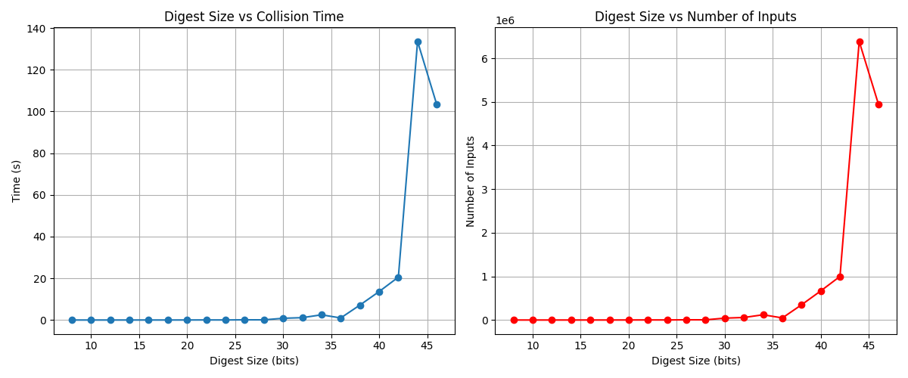

Answers to Questions

1. What do you observe based on Task 1b? How many bytes are different?
Observation of the Avalanche Effect
Based on our implementation, we observed a clear avalanche effect. This is a critical property of secure cryptographic hash functions, where a very small change in the input results in a large, unpredictable change in the output.
Specific Evidence
Across three iterations, we tested pairs of strings that differed by exactly one bit in their binary representation:
- Iteration 1: MzUAFRJFde vs. MzUAGRJFde resulted in a difference of 129 bits.
- Iteration 2: SYjLQQlMVK vs. SXjLQQlMVK resulted in a difference of 118 bits.
- Iteration 3: IAHPsQEiuK vs. IaHPsQEiuK resulted in a difference of 134 bits.
Bit-level Difference
On average, approximately half of the bits (127 out of 256) changed between the two hashes. This aligns with the theoretical expectation that in a strong cryptographic hash function, each output bit has a 50% probability of flipping when a single input bit is modified.
Byte-level Difference
At the byte level, nearly all 32 bytes of the 256-bit digest were different. Because hexadecimal encoding groups bits into 4-bit nibbles, even a single bit flip is sufficient to alter the value of a byte’s representation. As a result, the hexadecimal hash outputs exhibit no visible similarity.

2. Maximum files vs. expected hashes for collision (Birthday Bound)?
Maximum (Pigeonhole Principle):
To mathematically guarantee a collision on an n-bit digest, at least $2^{n}+1$ unique inputs must be hashed.
Expected (Birthday Bound):
Due to the Birthday Paradox, the expected number of hashes required to find a collision with approximately 50% probability is $2^{n/2}$.
Observations:
Our experimental results align with these theoretical principles. For example, at 40 bits, the expected number of hashes is $2^{20}≈1,048,576$. Our program found a collision after 667,261 attempts, which is well within the expected order of magnitude.
256-bit Speculation:
For a full SHA-256 digest, the birthday bound predicts that $2^{128}$ hashes are required to find a collision. Empirically, finding a collision at 44 bits took 133.59 seconds. Since each additional bit increases the collision search space by a factor of $\sqrt{2}$ (approximately 1.41), a 256-bit collision search would take roughly
$$133.59×2^{(256-44)/2}\text{ seconds}.$$
This corresponds to a timescale on the order of septillions of years, confirming that the full 256-bit hash remains cryptographically secure against collision attacks.

3. Breaking the one-way property (8-bit digest)?
Yes. With only 8 bits (( 2^8 = 256 ) possibilities), it is trivial to find a pre-image by brute-forcing approximately 256 inputs. Finding a collision is generally easier than finding a specific pre-image because the Birthday Paradox reduces the search space from ( 2^n ) to ( 2^{n/2} ).

